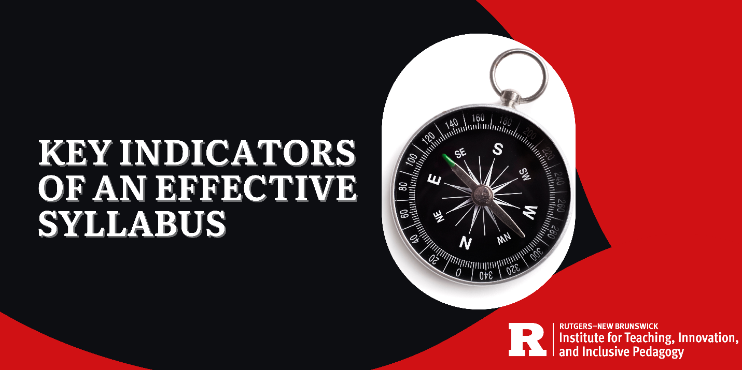

Key Indicators of An Effective Syllabus
An effective syllabus is a learning tool that conveys important information to students clearly and concisely, has a welcoming tone, is digitally accessible, focuses on learning and student engagement, and addresses learner diversity. This guidance document co-created with Rutgers students supports instructors in developing effective syllabi of various formats (traditional, graphic, video-based).

The Traditional Syllabus [Download Framework]
A conventional document containing important course-related information.

What to Include

Key information about the course
- Basic course information:
  - course name
  - course number/section
  - an engaging description
  - learning outcomes
  - National Association of Colleges and Employers (NACE) competencies
  - course location & modality
  - professional standards (as applicable)
  - link for course site
  - required & optional materials clearly indicated which include open educational resources as relevant
- Instructor information:
  - name (includes phonetic pronunciation and title as relevant)
  - contact information
  - brief bio
  - student (office) hours
- Course guidelines: transparent course policies with indications of any flexibility (e.g. attendance, grading, academic integrity, generative AI)
- Course schedule:
  - detailed with deadlines
  - learning objectives and topics
  - exam or project dates and relevant topics
- Student success resources:
  - course-based resources
  - campus resources
  - tips for how to succeed in the course
  - advice from previous students used with permission
- Changes: clearly indicates if the syllabus is subject to changes, the reasons for why changes could be made, and includes the date when the changes are effective

Has a clear and organized structure plus visuals
- Contains section headings
- Not lengthy with supplementary information posted on the course site
- Contains visuals such as simple cartoons and/or diagrams related to the course
- Embeds hyperlinks so that readers can easily go to the appropriate section or course site page
- Integrated into the “Syllabus” in Canvas so that it appears as a menu item to make it easier for students to find. You may need to enable the Syllabus on the Course Home Page. Expandable boxes are used as needed for additional information.

Is digitally accessible
- Contains headers, alt text for images, bulleted lists, and follows other recommended accessibility practices
- Follows the guidelines of An Accessible Syllabus in Rutgers Access and Disability Resources

Has a positive, student-centered tone
- The text is welcoming, inclusive, and exemplifies a growth mindset. See the examples below.
  - To help you succeed in this course...
  - To create a supportive learning environment, we will...
  - To give you opportunities to practice and obtain the skills you need...

What to Avoid
- Using punitive or weed-out language; instead, is transparent about the expectations of the course and, where applicable, shares summaries from past students’ experiences regarding course workload [Note: previous students are not identified unless permission is sought]
- Having restrictive availability of student hours (AKA office hours)
- Excluding critical information such as assignment deadlines
- Creating a lengthy document (e.g. 10+ pages)
- Requiring texts that will not be used in the course

The Graphic Syllabus [Download Framework]
A visual, one-page supplemental document that highlights important information from the traditional syllabus.

What to Include

Key elements from the traditional syllabus (see above) such as:
- Basic course information
- Goals of the course
- Major sections/chapters/modules of course
- Important due dates
- Digital accessibility, especially images (e.g. includes alt text)
- Positive affirmations about student learning (e.g., tips about notetaking, or ways to stay motivated)

Additional elements of a graphic syllabus to consider:
- Important information is centralized (e.g., all on one page)
- Simple description of main assignments
- Simple graphics and colors

What to Avoid
- Confusing colors or poor color contrasts
- Overlapping text
- A structure that is difficult to follow
- Lack of order and organization
- Unclear and unlabeled charts and diagrams
- Too much text and too small of a font size

The Video-Based Syllabus [Download Framework]
A brief introduction to the traditional syllabus in video format that can be posted on the course site. Can be uploaded prior to the start of a course as an introduction and can be useful for students enrolling in the course after the drop/add period.

What to Include

Many key elements of the traditional syllabus such as:
- Friendly and articulate tone of the instructor (i.e., convey how you teach)
- Basic information about course
- Goals of the course
- Major sections/chapter/modules of course
- Important due dates
- Visual aids or charts (should be explained in the video for accessibility)
- Positive affirmations about student learning or how to be successful (e.g., study tips or encouraging phrases about working hard during the semester)

Additional elements of a video syllabus to consider:
- Record videos through Rutgers Kaltura
- Keeping the video brief (i.e., between 5 to 7 minutes)
- Including video captioning and a downloadable transcript
- Ensuring that the instructor is visible for part of the video
- Using easy to understand and conversational language
- Talking directly to the camera as if speaking directly to the students
- Highlighting the mouse cursor or making it easy to see
- Indicating if showing different pages on Canvas
- Making additional videos for other important information (i.e., assignments, projects)

What to Avoid
- Reading directly from the syllabus
- Going over every detail for all assignments
- Too much scrolling through the video or moving from screen to screen

Resources
TIIP. Creating an Accessible Course. https://teaching.rutgers.edu/creating-an-accessible-course/
University Academic Affairs. Digital Accessibility. https://academicaffairs.rutgers.edu/digital-accessibility



