






GenAI as a Design Partner
Adapt, Create, Embed: Using GenAI in Your Own Teaching Practice



Overview of this Resource
This resource grew out of a conversation, not a mandate. Over three sessions in July, more than thirty of us, faculty, instructional designers, and academic support staff from across Rutgers, read The Science of Learning Meets AI together.
When we talked about what we wished GenAI could take off our plates, grading and rubric development topped the list. When we talked about where we saw ourselves on the book's own spectrum for GenAI use, most of us landed in Adapt or Create, modifying what we already had, or building something new, rather than letting GenAI reshape our teaching altogether. This resource is what came out of listening to that.

We also didn't take the book at face value. When it came to how the authors describe students working alongside GenAI, several of us found their framing less useful than Maha Bali's cake-making analogy, and said so. That same critical read shaped our companion resource, Designing AI-Aware Assignments, which uses Bali's analogy instead.
The two resources come from the same conversations, just pointed in different directions: that one is about the decision you make for your students' work, and this one is about whether you want GenAI's help with your own.
Once you've decided what role GenAI should play in your students' assignments, this resource turns to a separate, entirely optional question: would you like GenAI's help with your own side of the work, the drafting, the rubric-building, the noticing what worked and what didn't?



The authors of The Science of Learning Meets AI, Lewis Ludwig and Todd Zakrajsek, describe this as a kind of comfort curve, Adapt, Create, Embed, moving from small, familiar uses of GenAI toward it becoming a natural part of how you build and refine your teaching materials. This resource walks through that curve, with different examples and a place to start wherever you are.
This resource walks through that curve, with different examples and a place to start wherever you are.
If you'd rather not use GenAI for this either, for any reason at all, that's a complete and legitimate choice, and this resource will still be here if that changes.

Goals of this Resource
Whatever brought you here, curiosity, a specific task you're stuck on, or just wanting to see what this is about, you're in the right place.
For those curious, here's what this resource offers:
A low-stakes way to start, using GenAI to improve an assignment or material you already know well, before touching anything new.
A next step, when you're ready, using GenAI to build something you didn't have the time or capacity to make before.
A longer view, for those who want GenAI woven into the regular rhythm of refining their teaching, not as a special project but as routine practice.
Real examples, grounded in the book our community read together and in how Rutgers instructors are actually using these tools.

Where to Start
Designing and refining assignments takes time. Clarifying instructions, drafting a rubric, spotting what challenged students last time, all of it takes time many of us do not have.
GenAI can lend a hand with that work. Ludwig and Zakrajsek (2026) describe a gentle progression for it, Adapt, Create, and Embed, that meets you wherever you are.
You don't need to treat this as a checklist. Read the stage that matches where you are, try it, and come back for the next one whenever you're ready. Or skim all three now and return to whichever one is useful later.

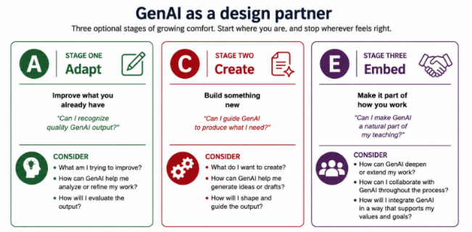



Figure 4. The ACE Framework. Adapted from Ludwig & Zakrajsek, The Science of Learning Meets AI (2026). Image created through ChatGPT Instant 5.5 (OpenAI), July 2026.


Design Method for AI-Aware Assignments

Adapt: Improve what you already have
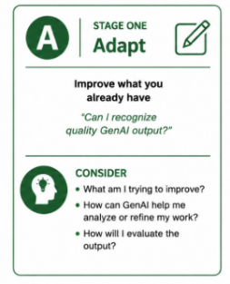
When you are ready to bring GenAI into your teaching, the most manageable place to begin is with an assignment you already know well.
In the Adapt stage, use GenAI to improve our existing materials, clarifying the instructions, and checking that the assignment still aligns with our learning outcomes. The guiding question, as Ludwig and Zakrajsek frame it, is "Can I recognize quality GenAI output when I see it?"
Starting here makes sense. When you adapt a familiar assignment, you are already the expert: you know what good student work looks like, where students tend to struggle, and what learning goal the assignment is designed to accomplish.
Because you know the material, you can tell which of GenAI’s suggestions are worth keeping and what to ignore. You are not trying to learn the technology and redesign the assignment at the same time.
This pairs well with the transparency work we referenced in our companion resource, Designing AI- Aware Assignments. Asking GenAI to help clarify an assignment's purpose, tasks, and criteria for students is one example of Adapt.

💡 For example: You take a set of discussion questions you have used for a few semesters and ask GenAI to flag any that might confuse students or to suggest clearer wording. The questions are still yours; GenAI just helps you sharpen them.

Create: Build something new
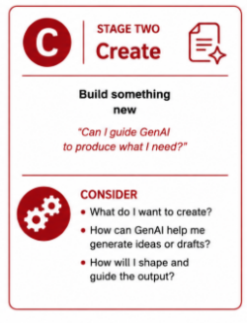
In the Create stage, use generative AI to make new assignments, ones that would have taken too long to build by hand. Rather than refining an existing assignment, you can create something new.
This could mean a rubric, a set of practice problems, or a bank of scenarios. At this stage, the question becomes "Can I guide GenAI to produce what I need?" Here, GenAI starts to expand what you can realistically offer students.
However, you want to make sure that whatever GenAI produces still receives our expert check before it reaches students. You are the one who know whether a generated rubric captures what actually matters, or whether a scenario holds up.
💡 For example: In an engineering course, you have GenAI generate a set of realistic design scenarios, each with different constraints, budgets, and failure conditions, that students then work through and troubleshoot. Writing enough varied scenarios by hand would take a lot of your time, so GenAI makes the assignment possible. You'll want to make sure you review each scenario for errors or unrealistic constraints before assigning it to students.

Embed: Make it part of how you work
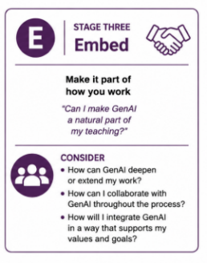
In the Embed stage, GenAI becomes a part of how you develop and refine your assignments over time.
The guiding question shifts to "Can I make GenAI a natural part of my teaching rhythm?" One of the most useful places for this is in looking at student work. After an assignment comes back, GenAI can help us see patterns across the whole set of submissions.
That information could help us revise the assignment for next time. However, you need to be especially careful at this stage. Student work is sensitive, so anything you put into a GenAI tool for this kind of review has to respect privacy and follow Rutgers' data guidance (see the next section). Used carefully, Embed helps us learn from our own assignments. Each time you teach one, you gain information that can make it stronger the next time.
💡 For example: After a lab report assignment, you use an approved GenAI tool to help summarize where students struggled most across the submissions. You notice that many students struggled with the same part of the analysis, which tells you the instructions for that step need to be clearer next semester.


A gentle note
These three stages are not a sequence everyone must move through, and "further along" does not mean "better." Adapting a familiar assignment now and then is every bit as valid as weaving GenAI through your whole design process. Start where you are comfortable, use what helps, and ignore the rest.

Rutgers Resources

From Rutgers IT
The Artificial Intelligence at Rutgers page is the place to start, and it is kept current as tools and policies change. A few things you will find there:
GenAI tools at no additional cost, available to students, faculty, and staff: Microsoft Copilot Chat, Gemini Notebook (formerly NotebookLM), and Google Gemini.
Data privacy guidance, including a data classification chart for AI tools that shows what kinds of information are and are not appropriate to enter into GenAI tools. Protected or identifiable student information should never be entered into a GenAI tool that has not been approved. See also Information Classification Policy 70.1.2.
University policies relevant to GenAI use, including Academic Integrity 10.2.13, Information Classification 70.1.2, and Acceptable Use of IT Resources 70.1.1.
General AI guidance and governance, including the AI@Rutgers Initiative steering committee and Rutgers' guidance on the use of AI.


AI literacy resources, including a growing library of LinkedIn Learning courses on generative AI, covering prompt design, ethical implications, and practical uses.

From the Institute for Teaching, Innovation, and Inclusive Pedagogy (TIIP)
TIIP offers ongoing spaces to think through this work together. This resource grew out of those conversations, and we would love to have you join us.
Teaching and GenAI Pathways Program. A self-paced program where you can work through milestones in generative AI teaching practices. Earn digital badges along the way.
GenAI Community of Practice. A monthly space to think through live questions about generative AI with colleagues, grounded in real classroom practice. Come to share what you are trying, or just to listen and hear what others are doing.
Additional Emerging Technologies Resources: The Institute for Teaching, Innovation, and Inclusive Pedagogy has developed and curated other resources, including advice for students.

Other Campus resources
Support for teaching with GenAI comes from many different spaces across Rutgers. A few worth knowing about:
Teaching Critical AI Literacies (SAS, Critical AI).
Critical AI, a Rutgers-based interdisciplinary journal and initiative, offers critical perspectives on generative AI along with peer-reviewed classroom resources for teachers and students.
AI in Teaching Libguide (Rutgers University Libraries). Includes sample syllabus language, plus some examples of AI literacy assignments.

Artificial Intelligence Libguides (Rutgers University Libraries). Start here for a grounding in generative AI terminology, plus how to cite it.
UOES Resource Library (University Online Education Services). Practical guides for online and hybrid courses, including assignment instructions when using GenAI
Critical Approaches to AI (Rutgers University Libraries). A look at the ethical, environmental, and labor concerns surrounding generative AI.

Acknowledgements
Thank you to the TIIP team and colleagues in TIIP's GenAI Community of Practice who read early drafts and offered feedback that shaped this resource.
We want to especially thank Tatiana Rodriguez (School of Communication and Information; School of Management and Labor Relations) for her contribution: catching a gap in the cake-making analogy, offering a sharper way to think about student ownership of GenAI-assisted work, and contributing the classroom example behind the AI-Free by Design section.

GenAI Disclosure Statement
Claude (Anthropic) was used in developing this resource to assist with structure, research summarization, drafting, and graphics. All framing, pedagogical decisions, and final content were determined and reviewed by the author. This disclosure models the practice the resource describes: considering generative AI's role deliberately and being transparent about the choice.

References
Bali, M. (2024). Cake-Making Analogy for Setting Generative AI Guidelines/Ethics. In Buyserie, B. & Thurston, T. N. (Ed.), Teaching and Generative AI: Pedagogical Possibilities and Productive Tensions. Utah State University. https://doi.org/10.26079/e204-acc5

Ludwig, L., & Zakrajsek, T. (2026). The Science of Learning Meets AI. Routledge. https://doi.org/10.4324/9781003689102

